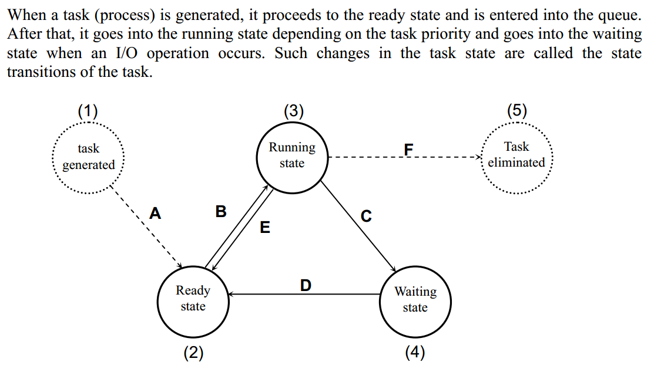

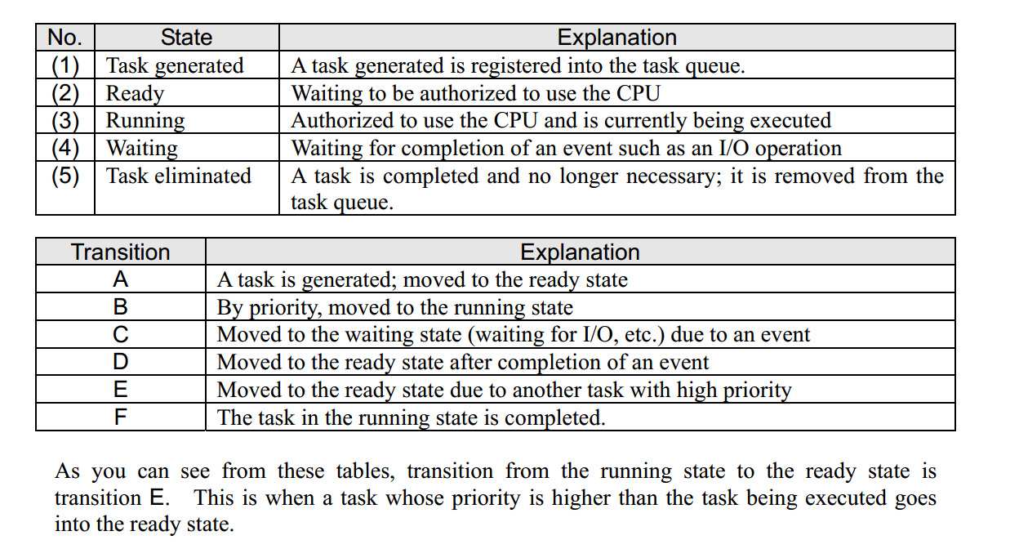

Run or ready based on priority. Remember two states (running and ready) are the opposite of each other.